Week-5
Q1: What are the key limitations of traditional MapReduce that make Spark a preferred choice for modern big data processing?
ANSWER 1:
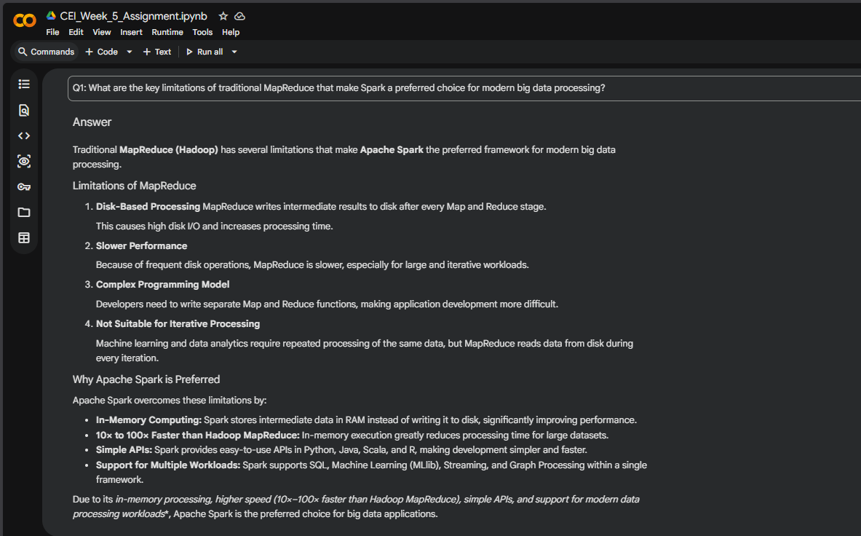
DONE IN A MARKDOWN CELL ON Google COLAB.

Q2: Explain how Spark uses In-Memory Computing to speed up iterative machine learning algorithms compared to disk-based systems.
ANSWER 2:
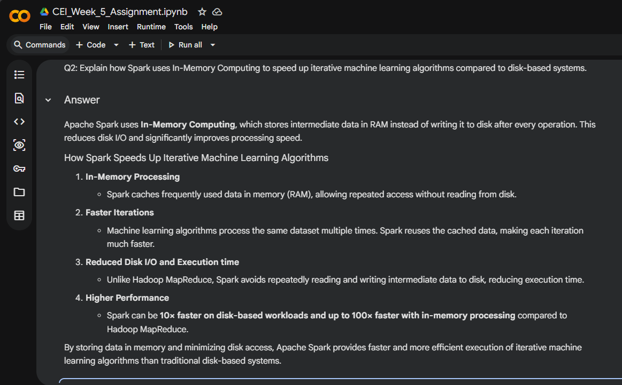
DONE IN A MARKDOWN CELL ON Google COLAB.

Q3: Write a code snippet to remove all duplicate rows from a DataFrame based on a specific set of columns: user_id and transaction_date.

ANSWER 3:
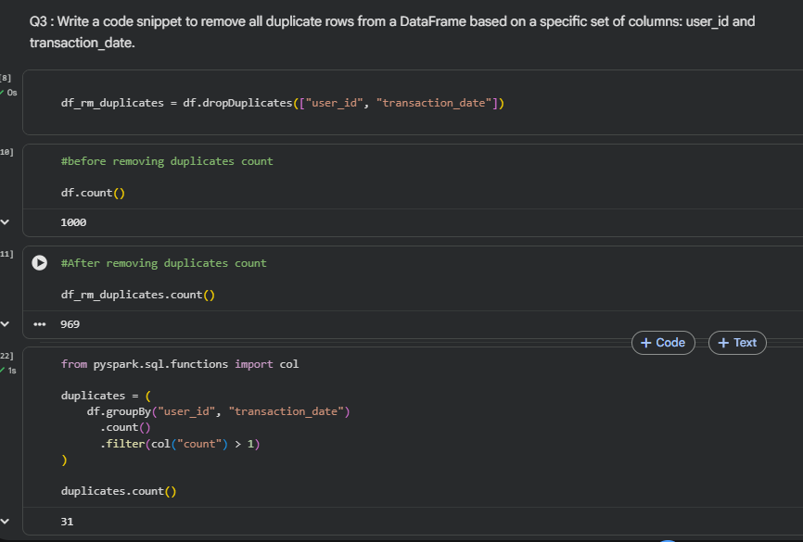

Q4: Given a DataFrame df_sales, write a query to filter for rows where the region is 'West' and then group by product_category to find the average sale_amount.

ANSWER 4:
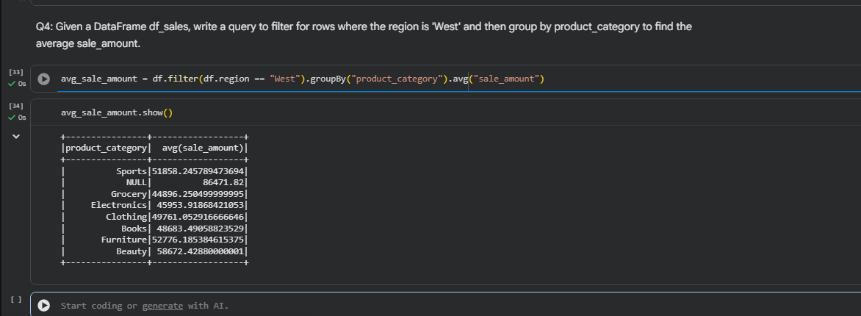

Q5: What is the difference between .na.drop() and .na.fill()? Provide a code example of filling null values in a status column with the string 'Unknown'.

ANSWER 5:
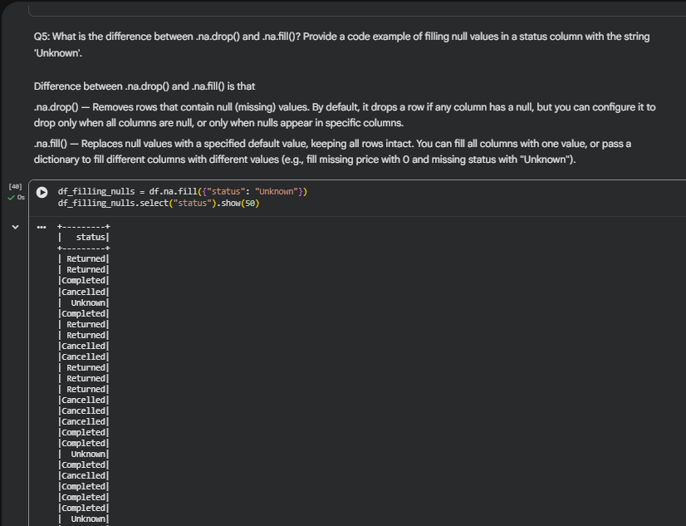

Q6: Write a query to find the total count of records for each city in a DataFrame, but only for cities where the count is greater than 100.
ANSWER 6:
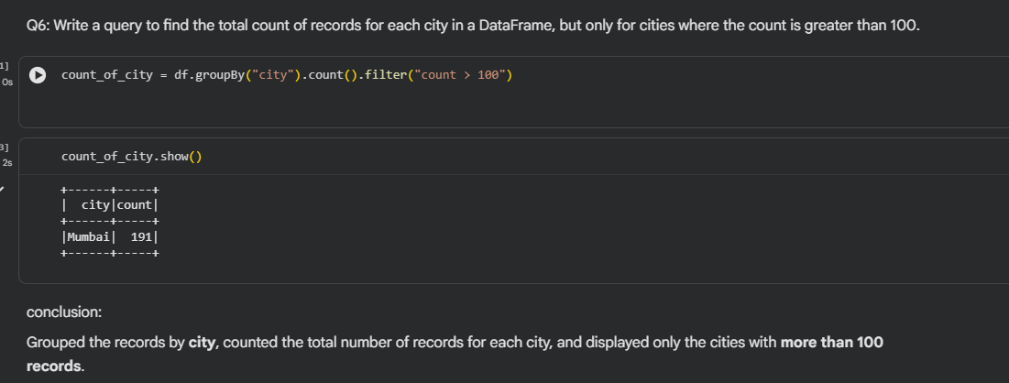

Q7: How does the immutability of Spark DataFrames affect how you perform "data cleaning" steps like dropping columns or renaming them?
ANSWER 7:
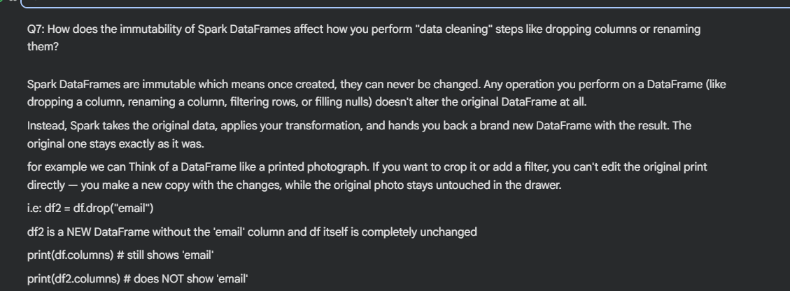
DONE IN A MARKDOWN CELL ON Google COLAB.
Q8: Write a Spark command to filter a dataset for rows where the age is between 18 and 30 (inclusive) and the subscription is 'Premium'.

ANSWER 8:
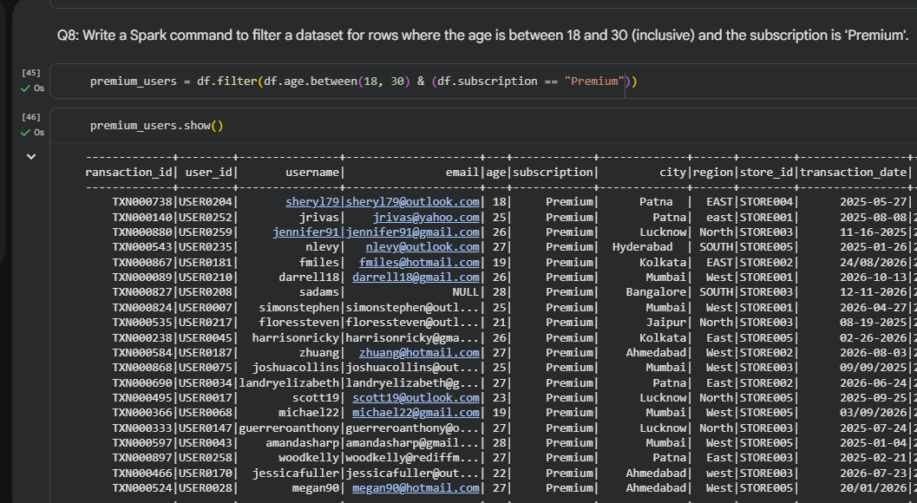

Q9: When cleaning a dataset, why is it often better to handle null values before performing mathematical aggregations like sum() or avg()?
ANSWER 9:
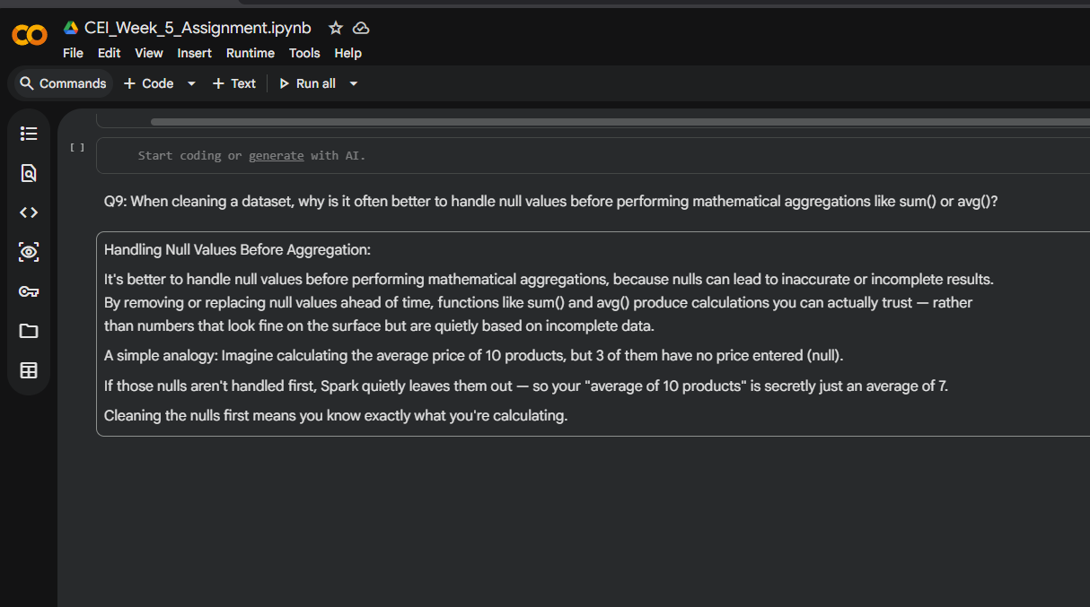

Q10: Write the code to revise a column named raw_timestamp by casting it to a TimestampType and renaming it to event_time.
ANSWER 10:
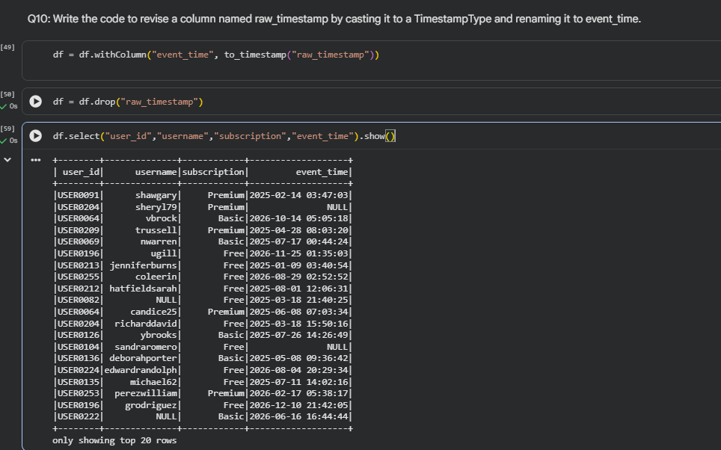

Q11: Explain the "Shuffle" process that occurs during a grouping operation. Why is it considered a wide transformation?
ANSWER 11: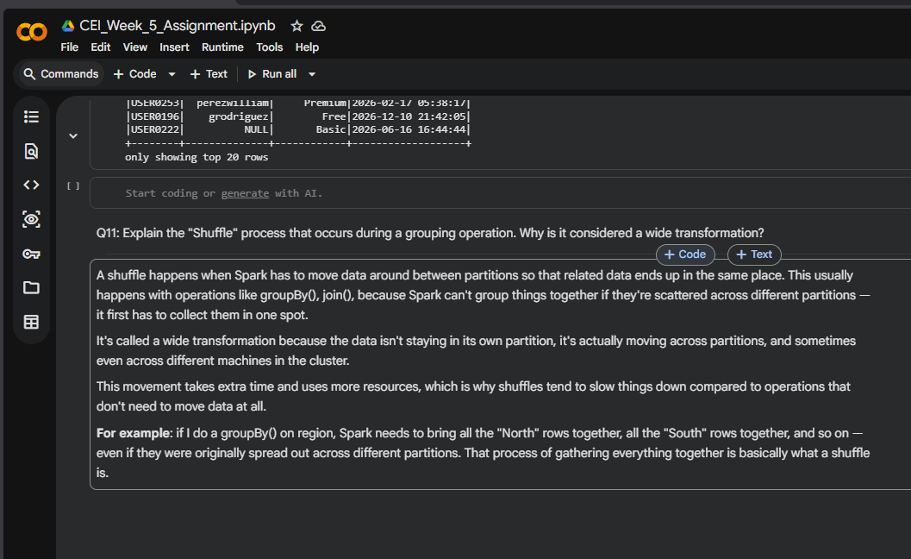

Q12: Write a code snippet that identifies and removes rows where the email column contains null values OR the username is an empty string.
ANSWER: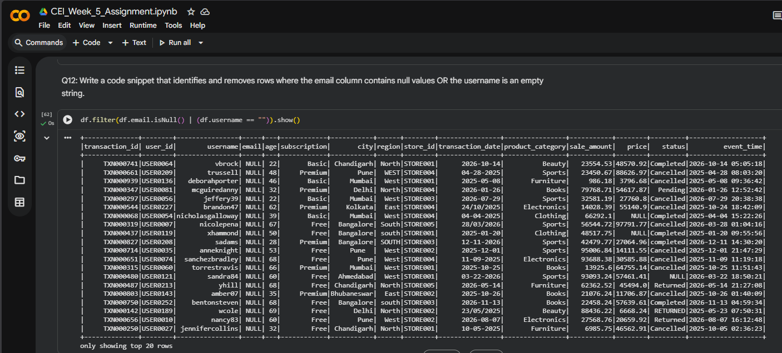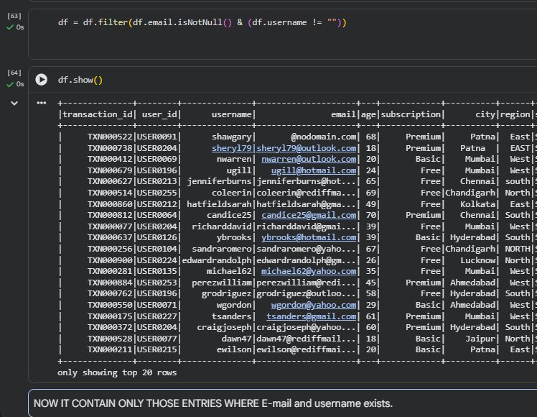
Q13: How do you use the .agg() function to calculate multiple statistics at once, such as the min, max, and mean of the price column?

ANSWER 13:
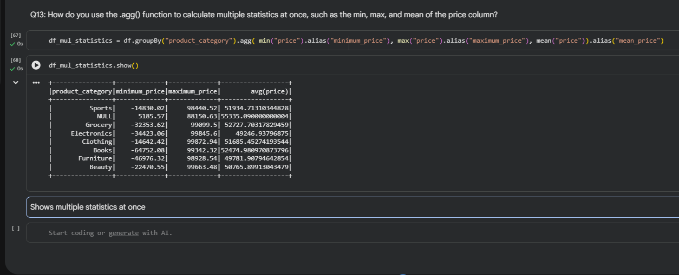

Q14: In the context of cleaning a dataset, what is the risk of using inferSchema=true when your source data contains messy or inconsistent date formats?

ANSWER 14:
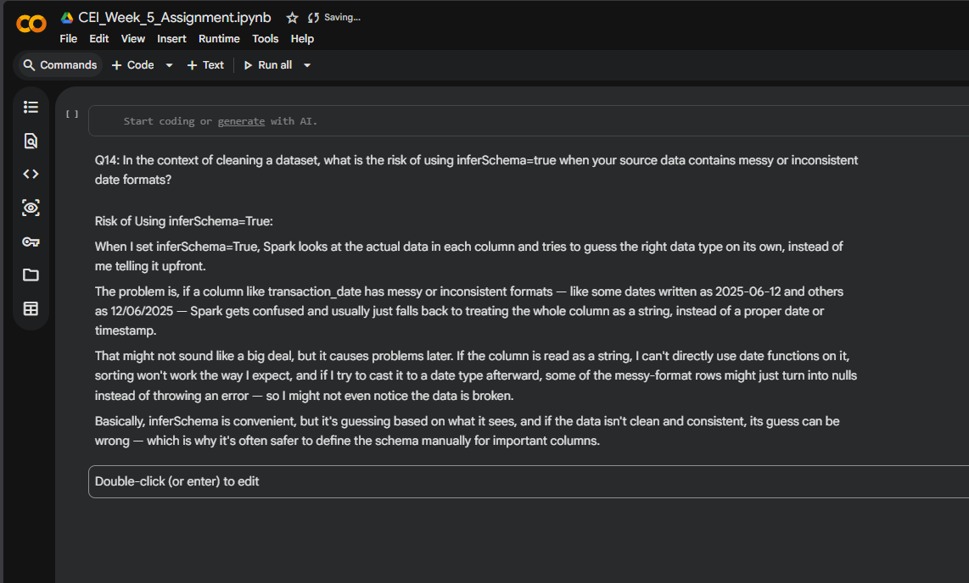

Q15: Write a final processing pipeline that:
- Filters out duplicates.
- Fills null prices with 0.
- Groups by store_id to calculate total revenue.

ANSWER 15:
